**Report Website Sell Wear**

Category

1. Activity Diagram
2. Images Demo
3. About me (author)
4. Activity Diagram :

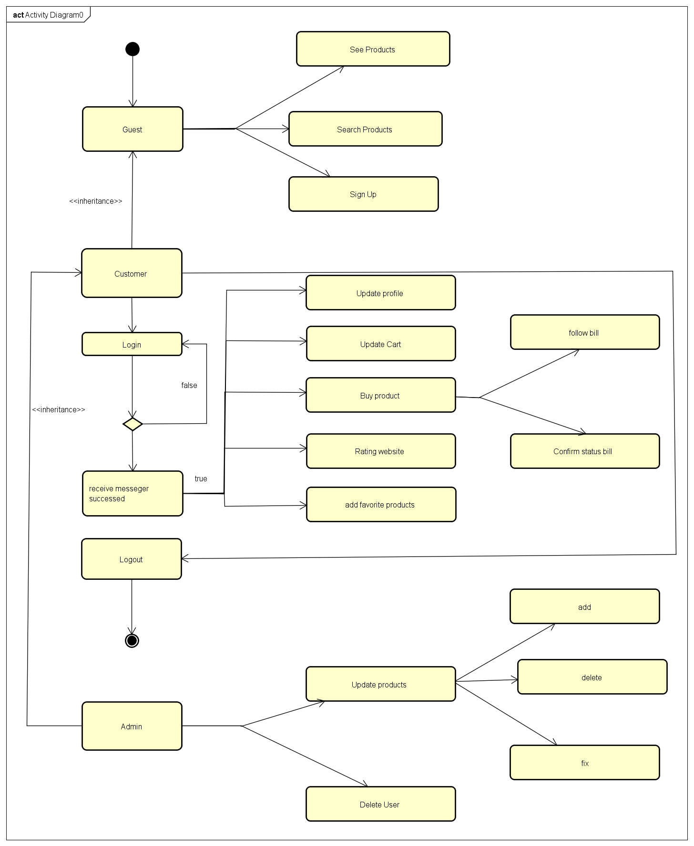

1. Image Demo :
   1. Sigup :

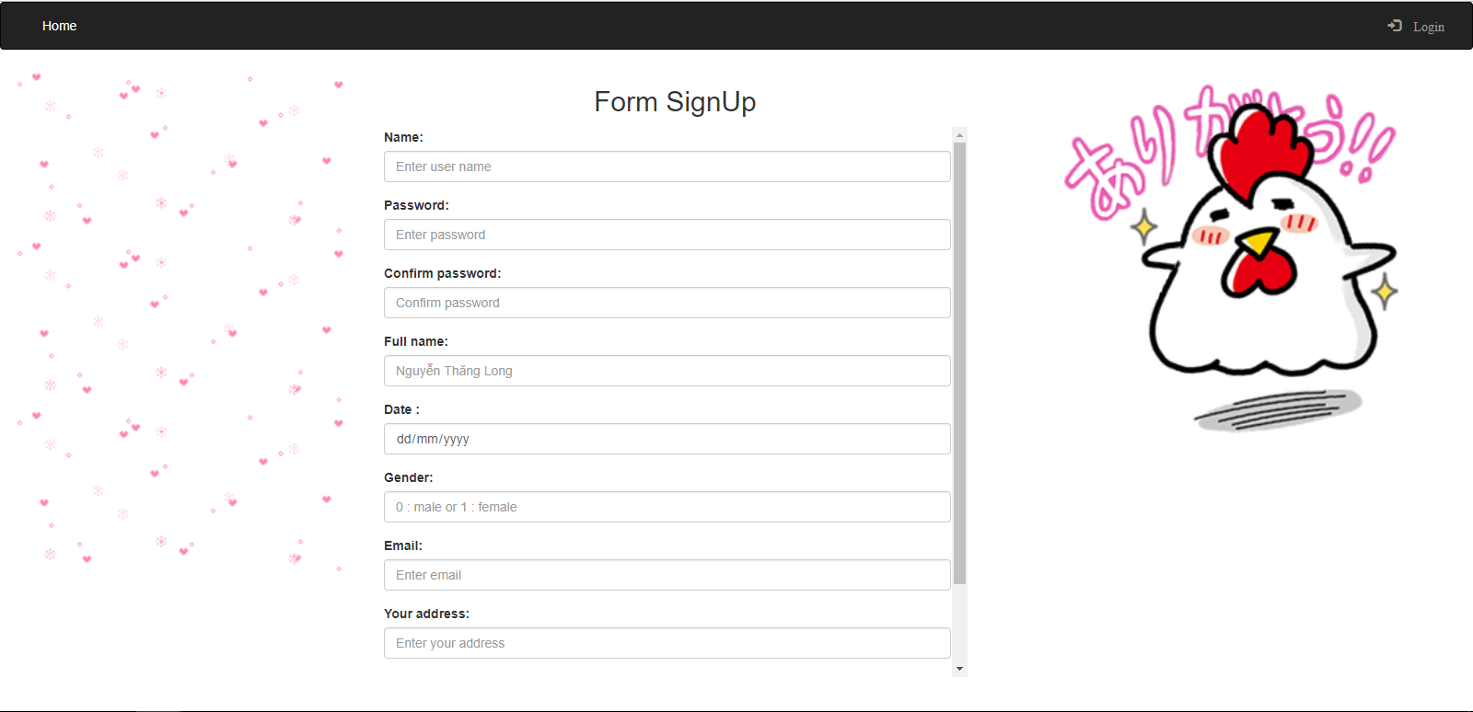

* Log In :

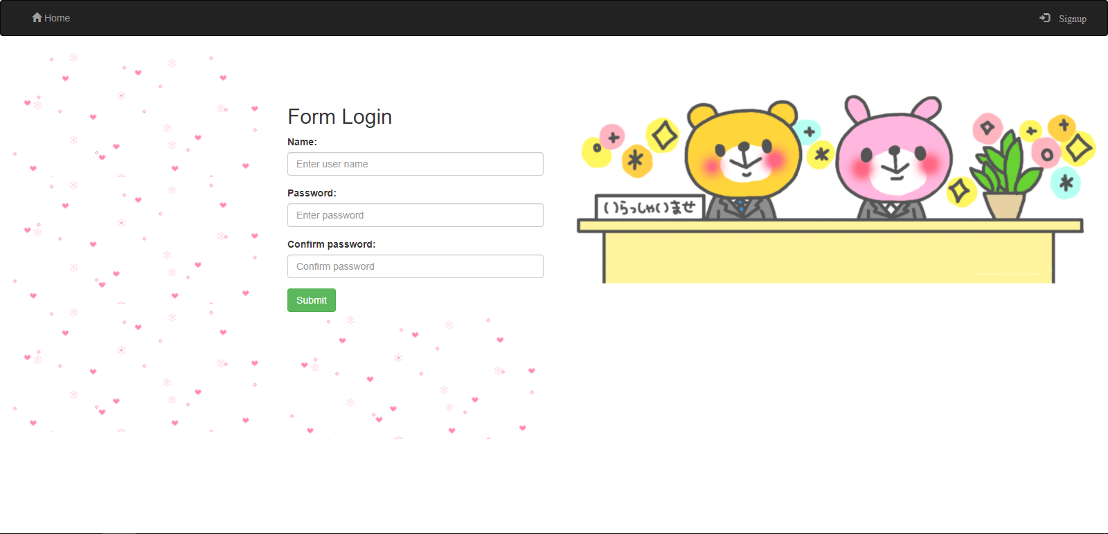

* Home Guest :

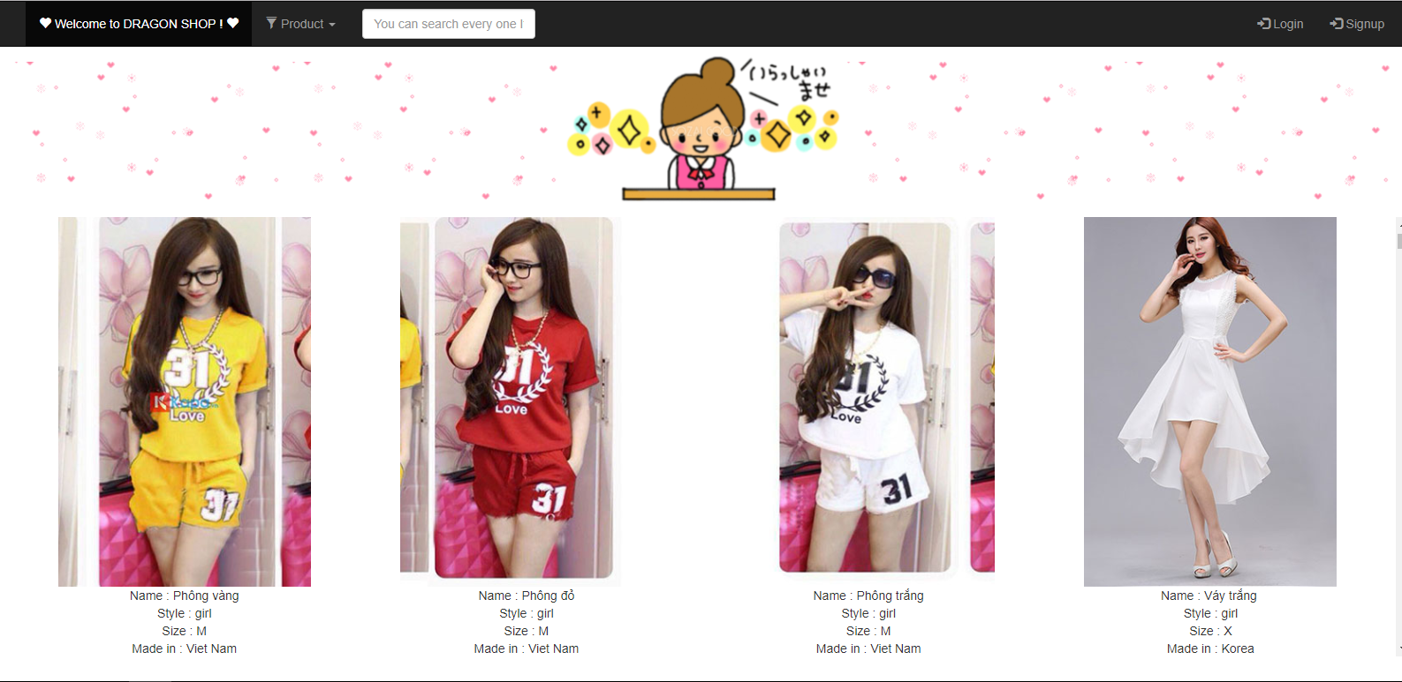

* HomeCustomer :

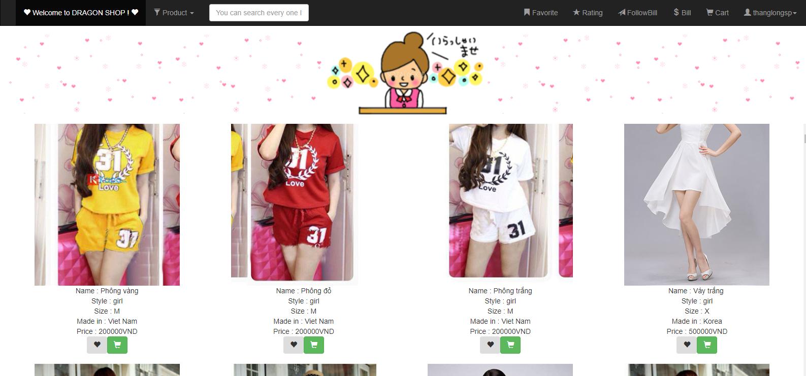

* Favorite page :

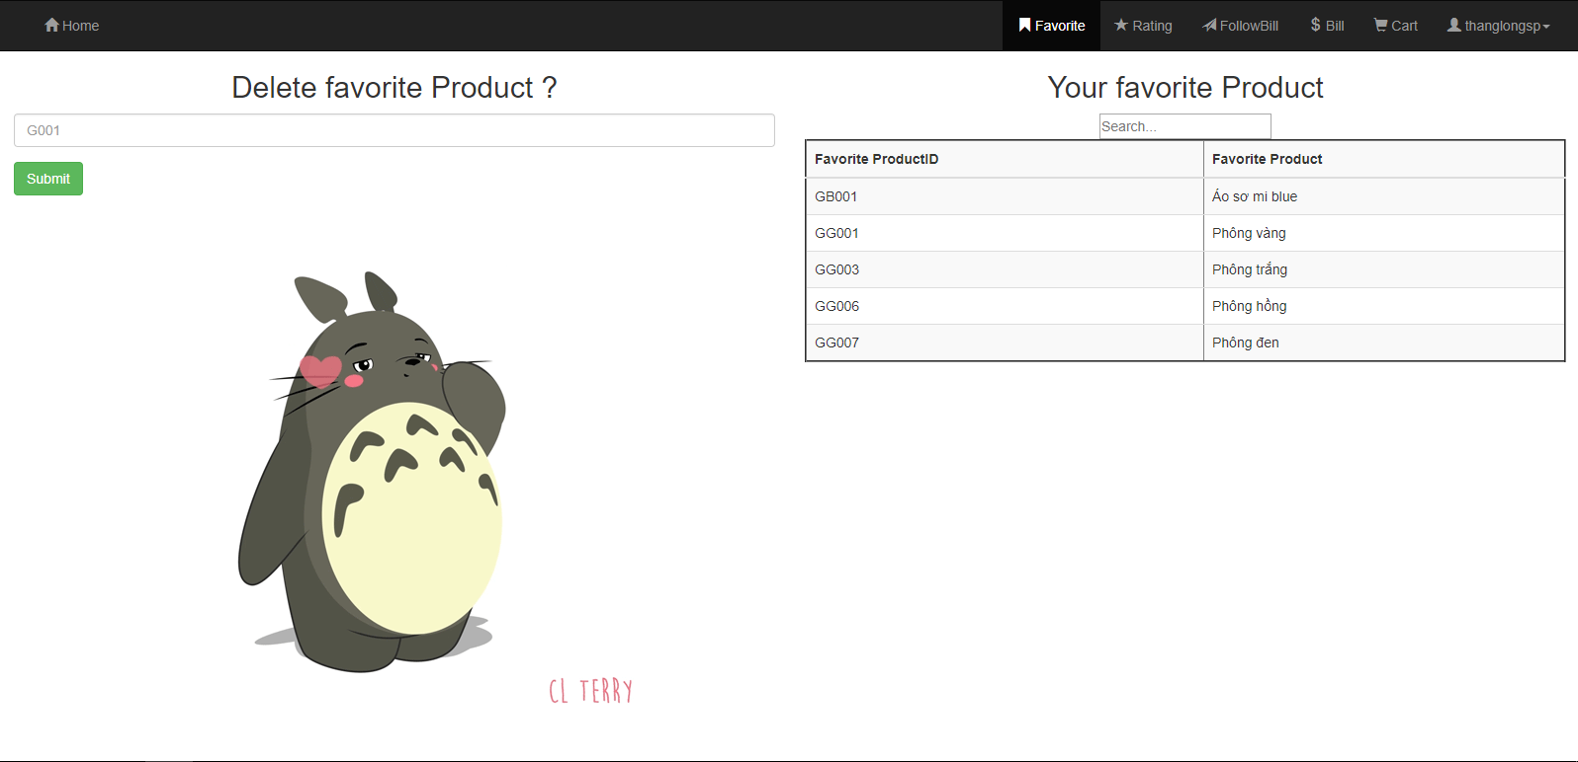

* RatingPage :

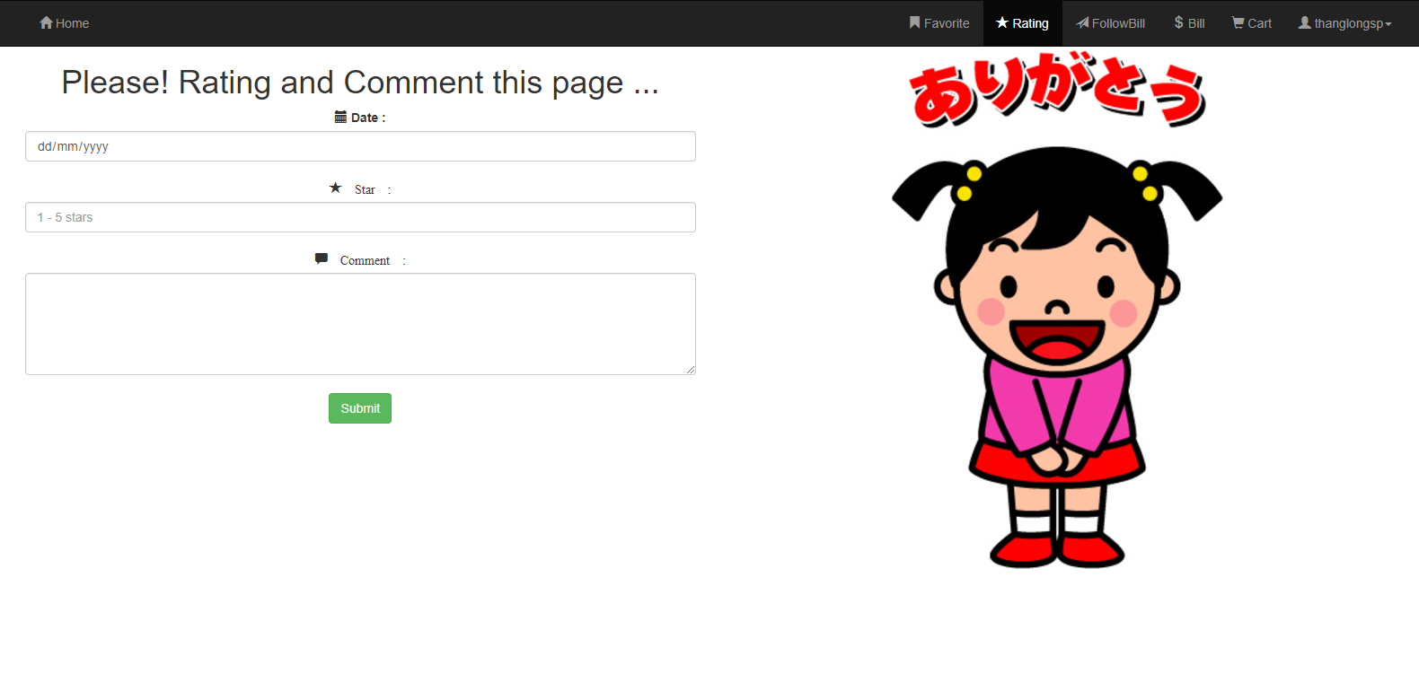

* Cart

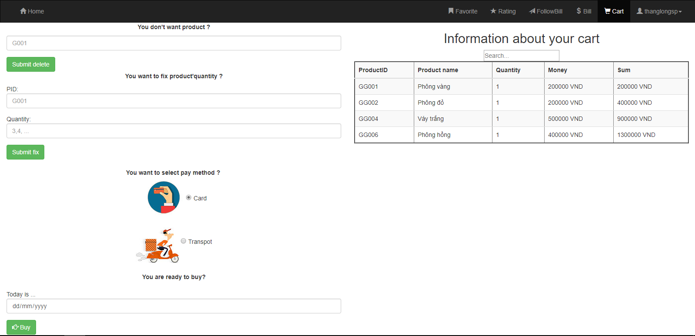

* Bill

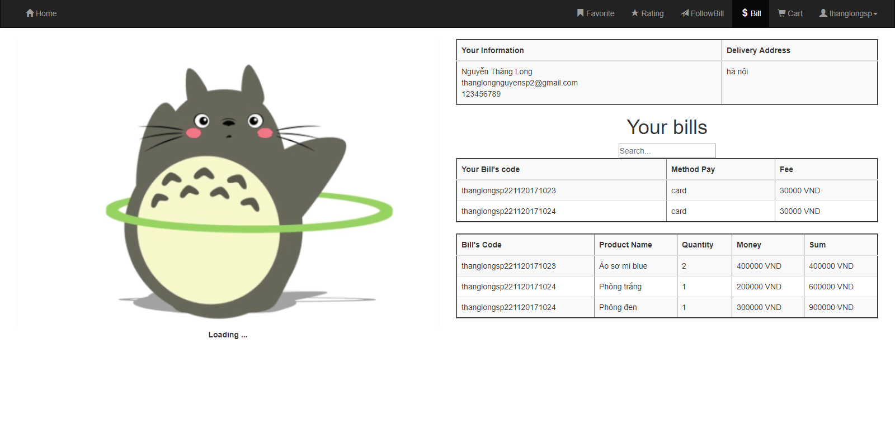

* followBill

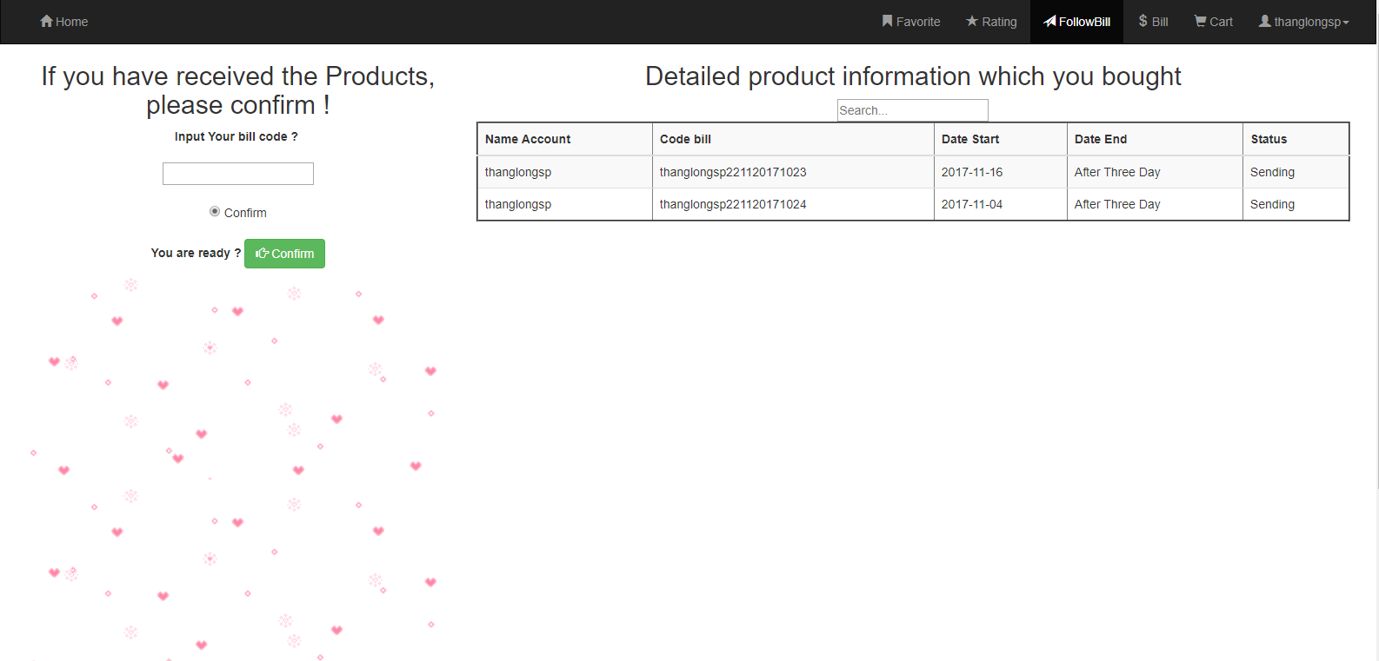

* Profile

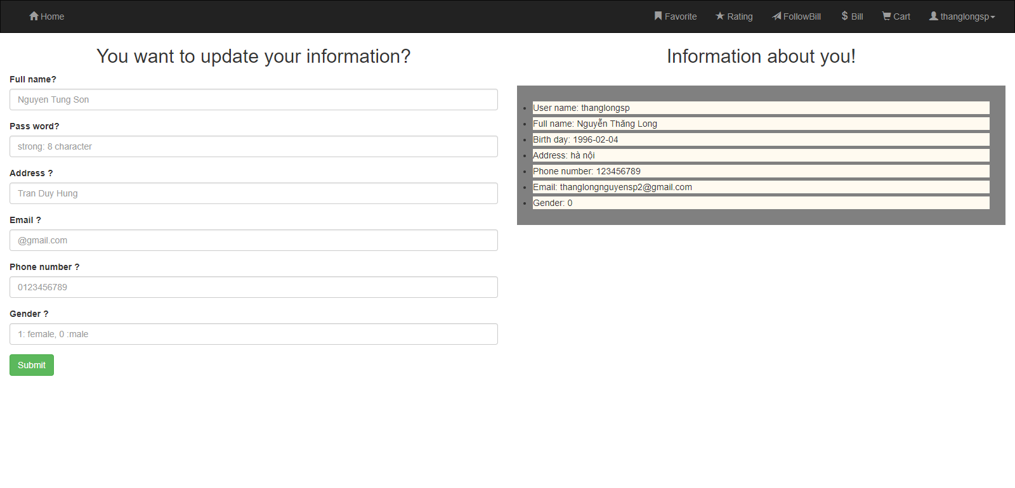

* Home Admin

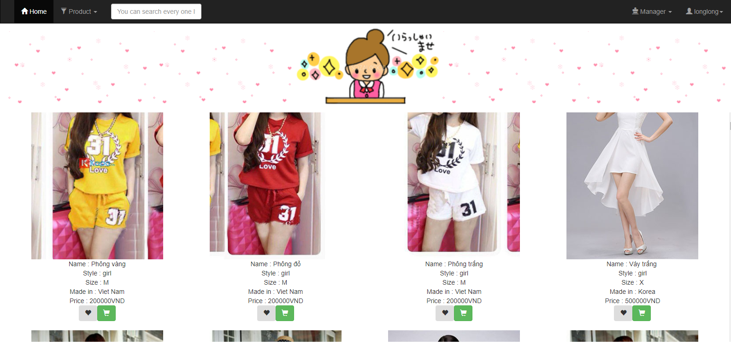

* Update product

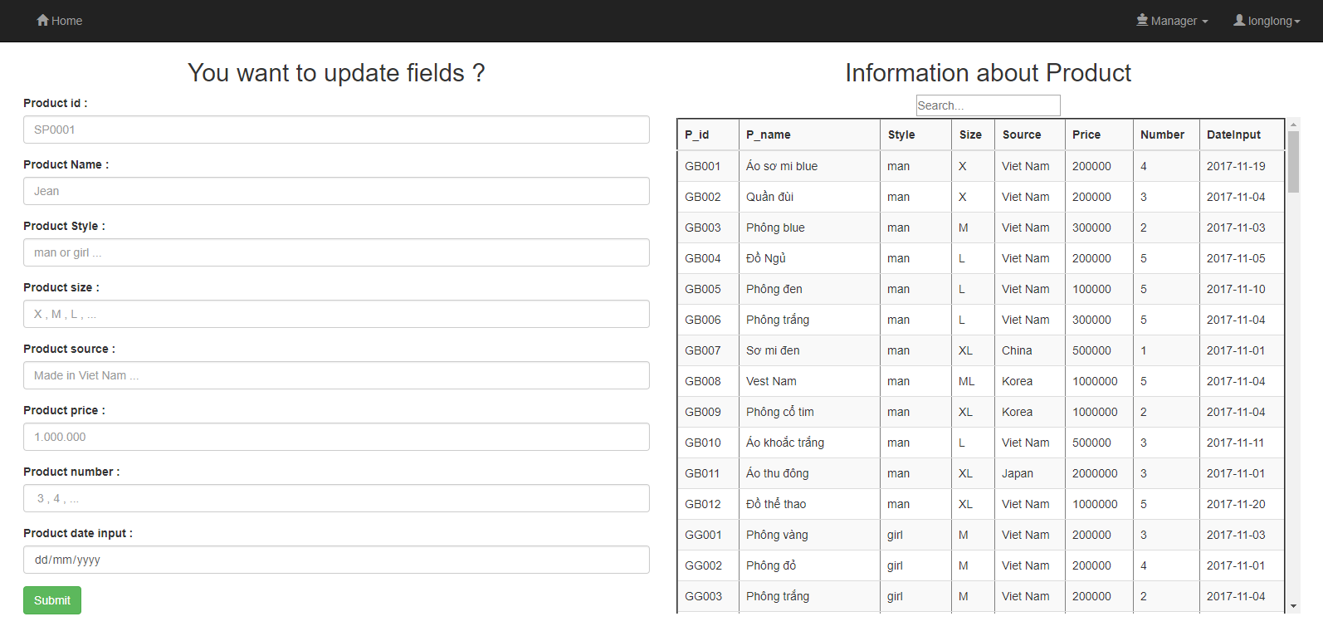

* Add product

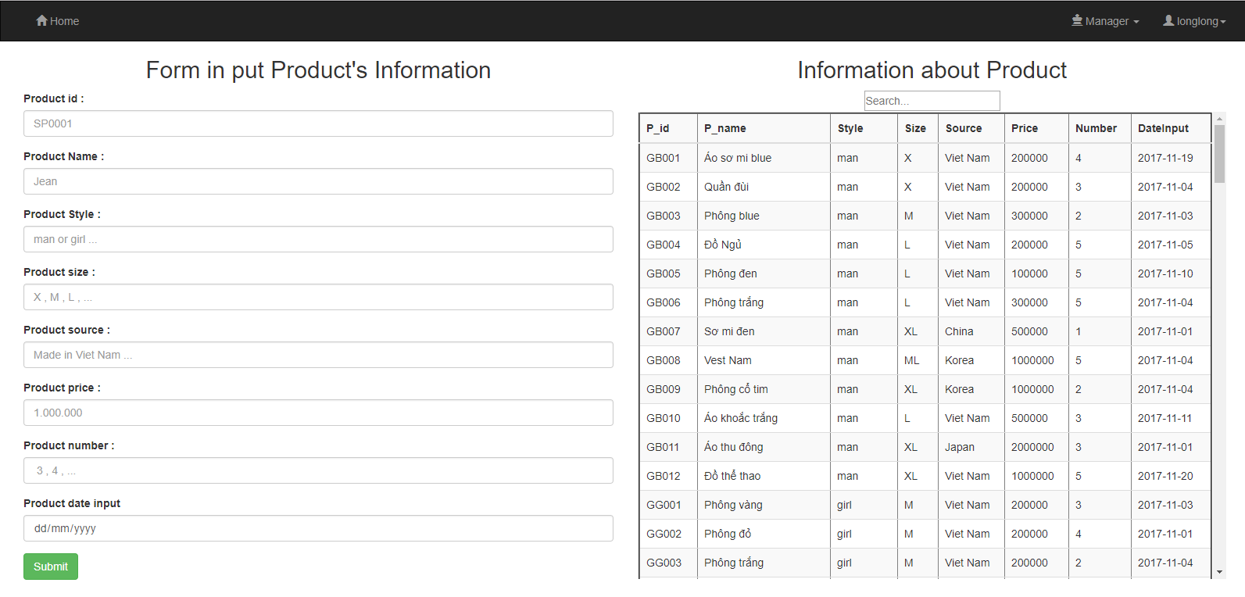

* Delete Product :

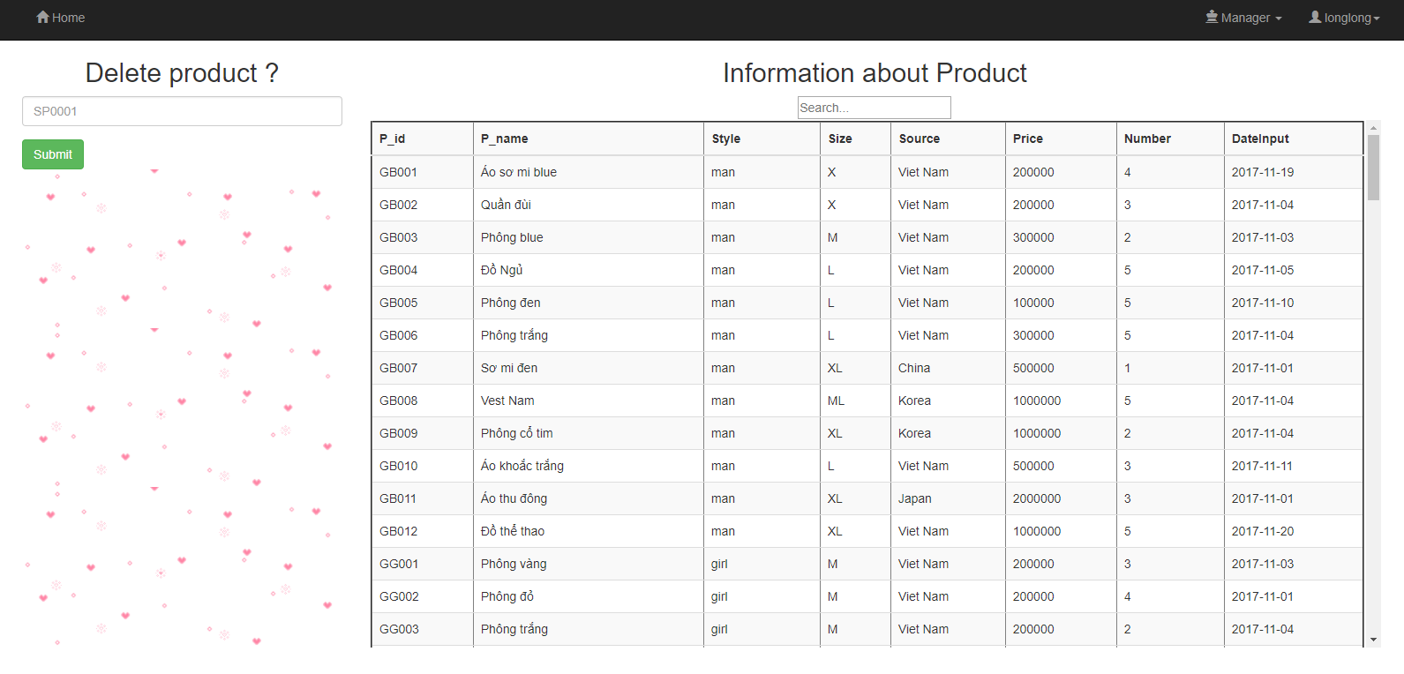

* Delete User

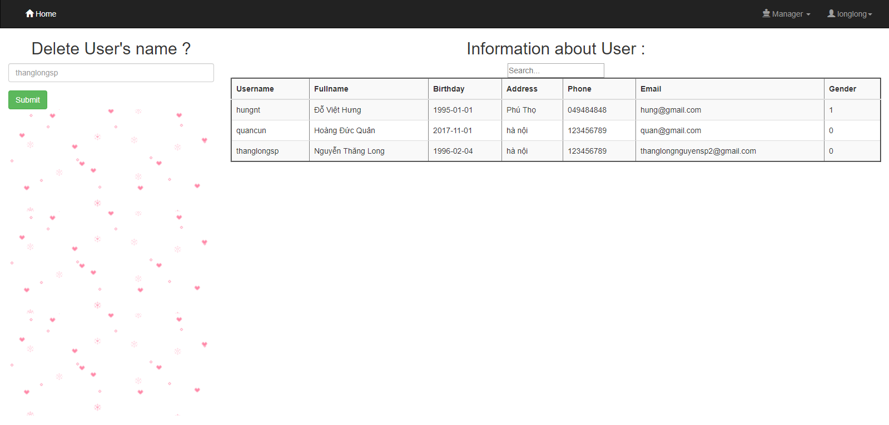

1. Author:

* Product by **Nguyễn Thăng Long** , student at Hanoi University of science and technology. Completed for 3 weeks.
* Tool :
  + Mysql
  + Sublime
  + PHP
  + Bootstrap
  + Css
  + Html
  + Ajax